Q.1
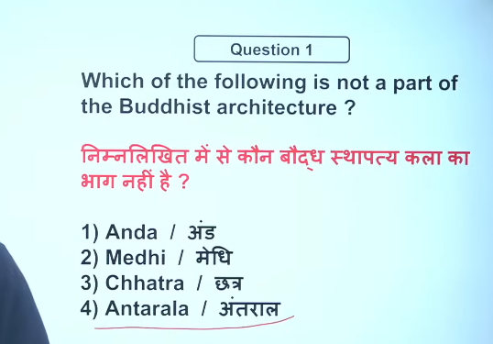

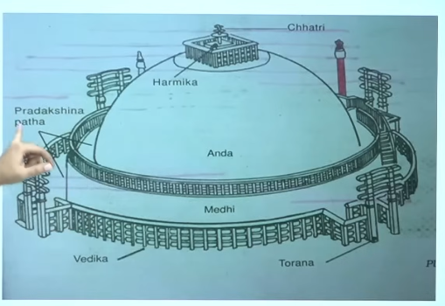

2
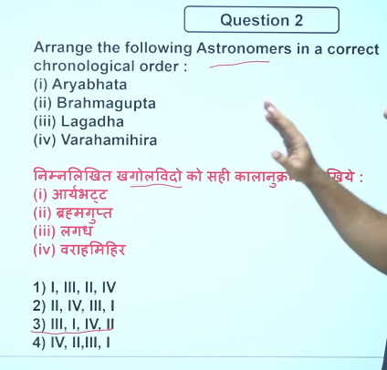
1200-1000 BCE 12-11 Bce
476–550 CE) 5^{th -}6th CE

(505–587 CE)-6th CE
7th CE (598–668 CE)
- 5th century CE → 401–500
- 9th century CE → 801–900
- 10th century CE → 901–1000
- 11th century CE → 1001–1100
- 12th century CE = 1101–1200 CE 📚

1200 BCE – 1000 BCE का समय 12th century BCE से 11th century BCE के बीच आता है।
- 5th century BCE → 500–401 BCE 📚
- 1100–1001 BCE → 11th century BCE
- 1200–1101 BCE → 12th century BCE

- 👉 An astronomer is a scientist who studies stars, planets, and the universe.
- 👉 खगोलशास्त्री वह वैज्ञानिक होता है जो तारों, ग्रहों और ब्रह्मांड का अध्ययन करता है। 🌌📚

Lagadha is a pioneering ancient Indian mathematician and astronomer credited with authoring the Vedānga Jyotiṣa, generally dated to around 1200–1000 BCE. While the text itself might have been compiled or finalized closer to 700–600 BCE, its astronomical, lunar, and solar observations reflect a Vedic period tradition, placing his work within that era.
Aryabhata (476–550 CE) 5th was a pioneering Indian astronomer and mathematician of the Classical Age who flourished in the late 5th to mid-6th century. His magnum opus, the Aryabhatiya, was composed in 499 CE at age 23, providing revolutionary, accurate calculations on planetary motion, eclipses, and a near-accurate value of

Varahamihira (c. 505–587 CE)-6th was a renowned Indian astronomer, mathematician, and polymath who flourished during the 6th century CE. Based in Ujjain, he was a key figure in the Gupta period's intellectual renaissance, known for his work in the Panchasiddhantika and Brihat Samhita, which synthesized earlier Indian, Greek, and Roman astronomical knowledge.
Brahmagupta (598–668 CE) was a prominent 7th-century Indian mathematician and astronomer from the Gupta dynasty period. He authored the Brāhmasphuṭasiddhānta (628 CE) at age 30, a foundational text for astronomical calculations and the first to treat zero as a number. He also wrote Khandakhadyaka (665 CE).

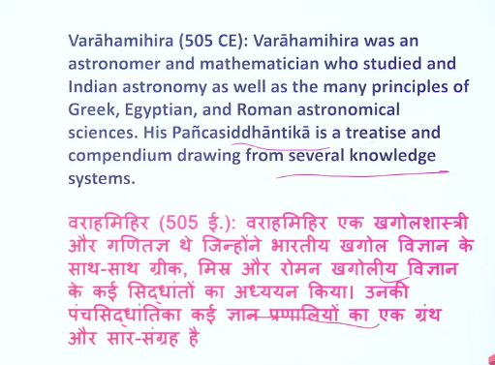

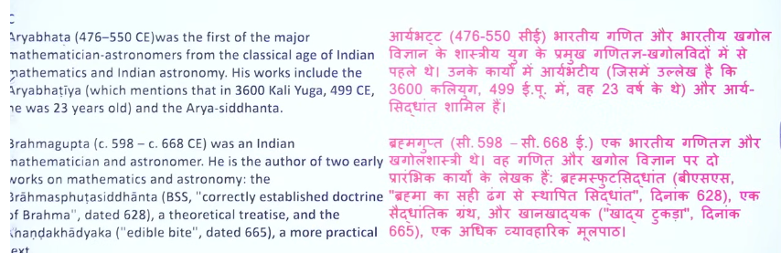
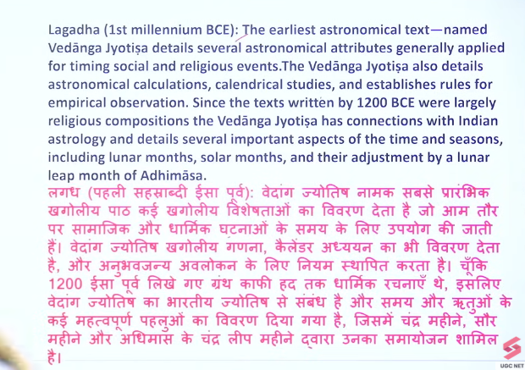

3
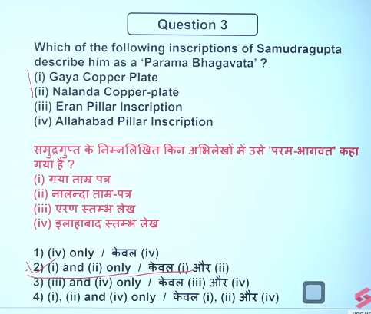

4

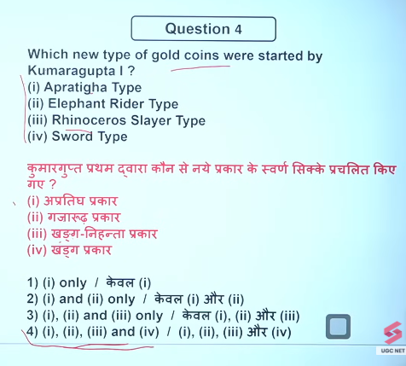

5
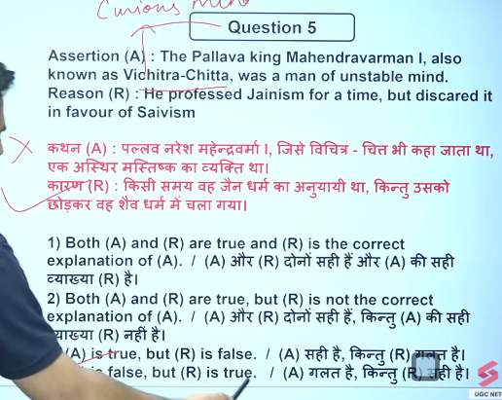
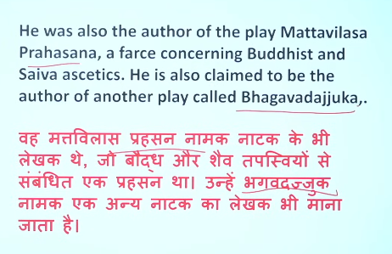
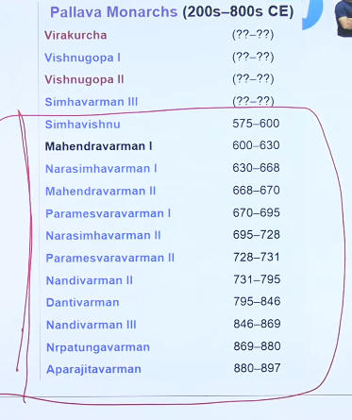

6
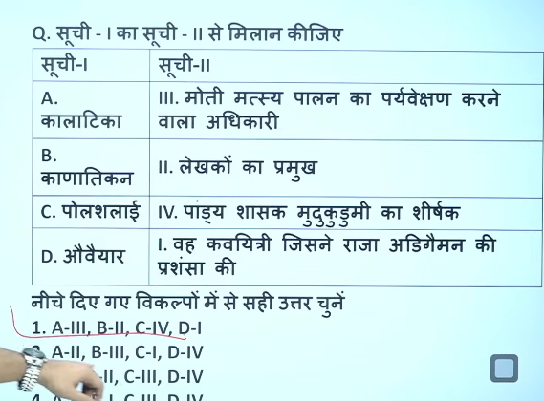

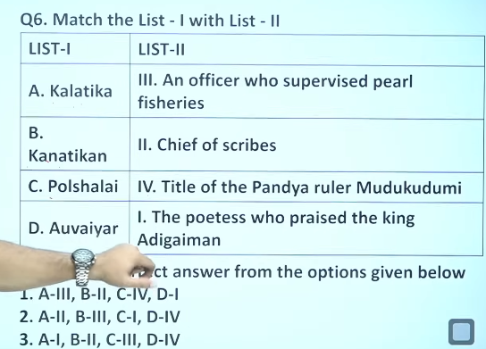

7
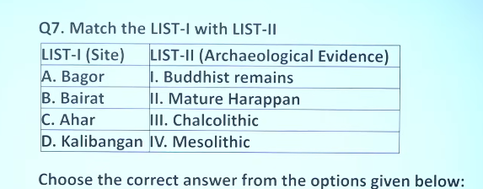
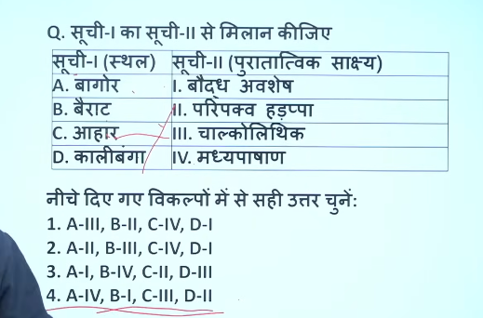

8
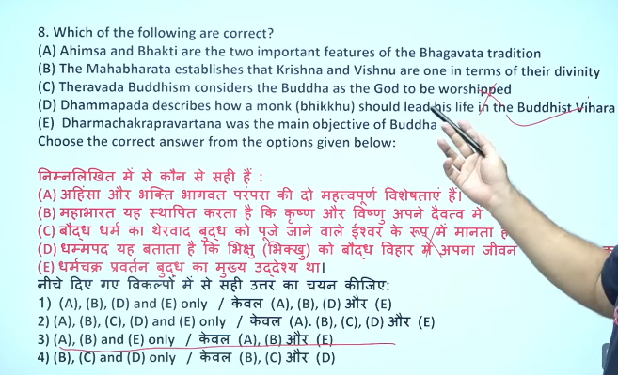

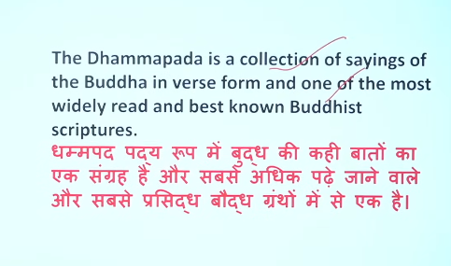

9
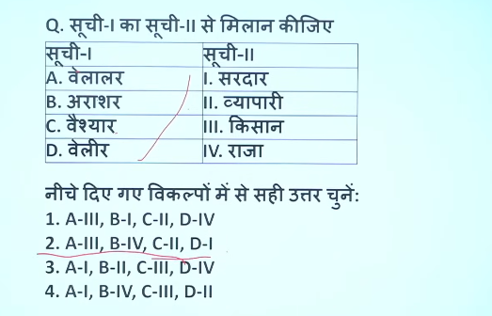
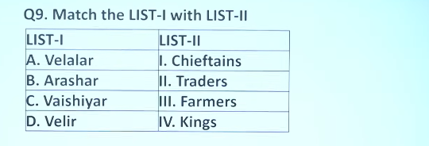

10
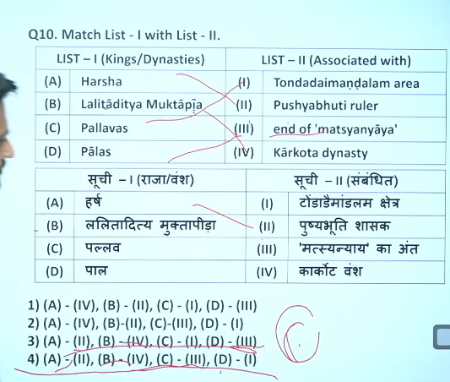
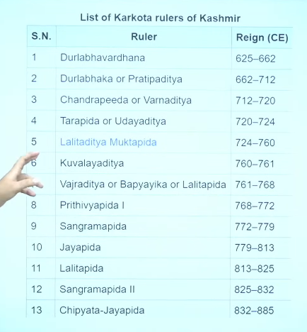

11
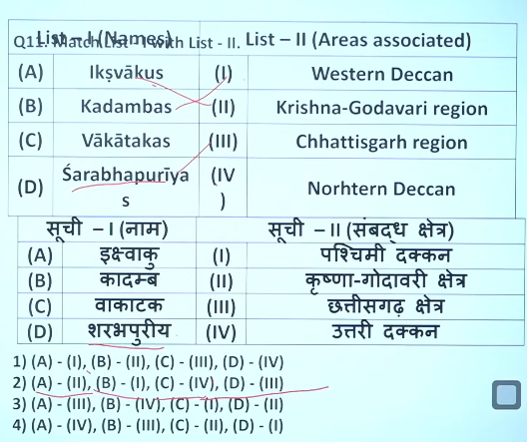

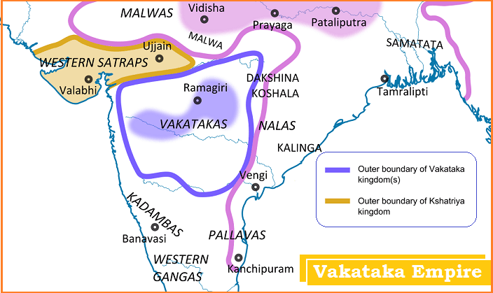

12
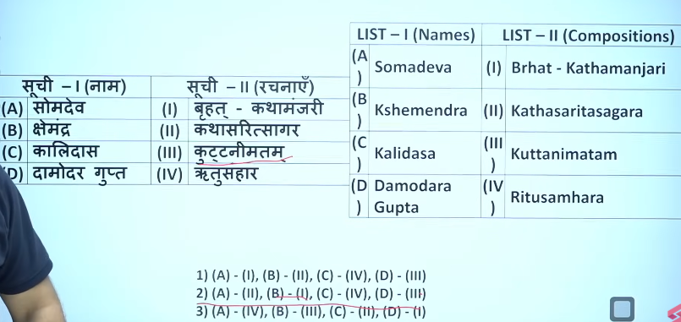

13
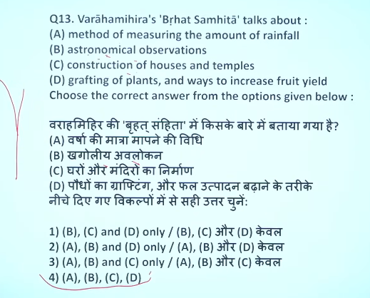
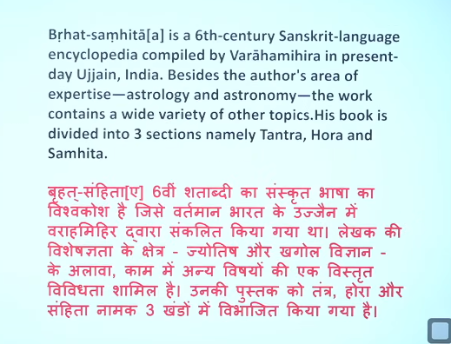

14
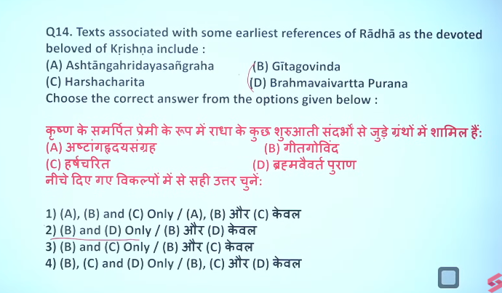
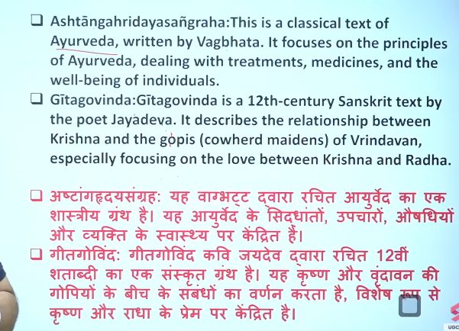

[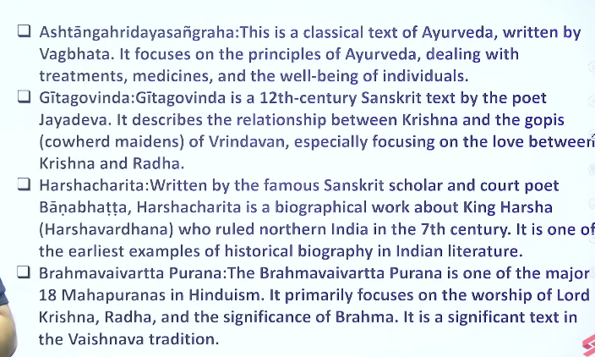
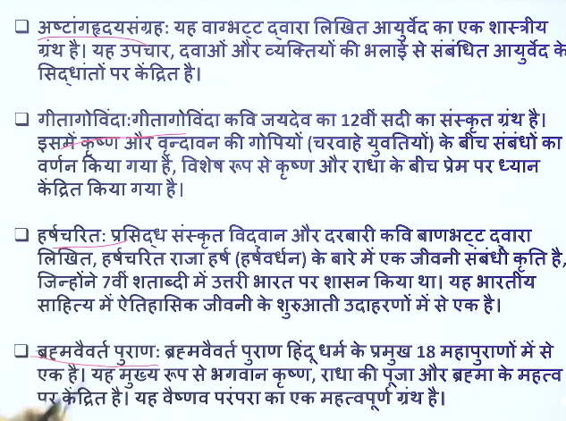

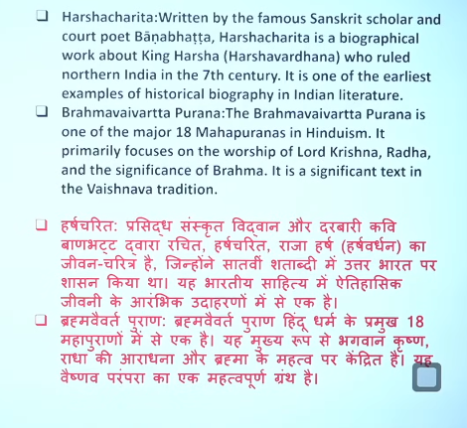

15
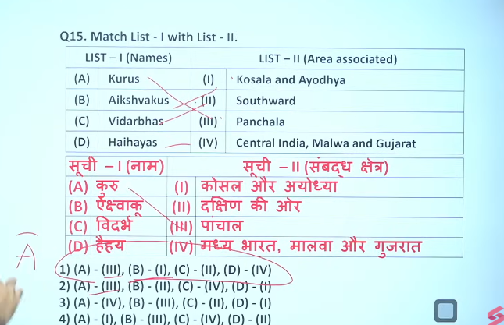

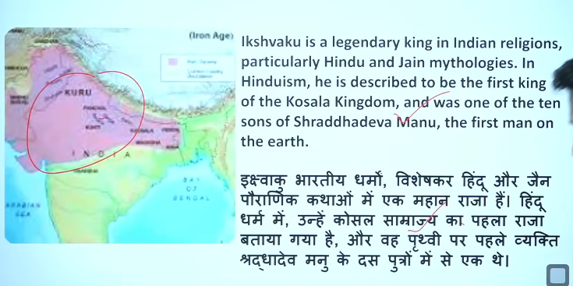

16
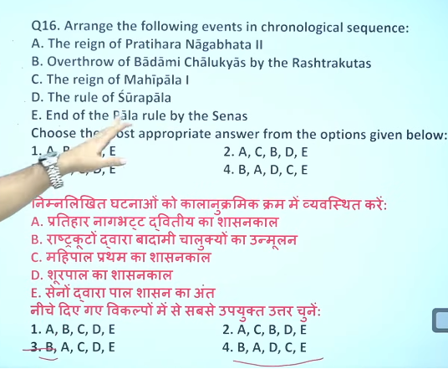
10 CE
805-833 CE
753 CE
988-1038 CE
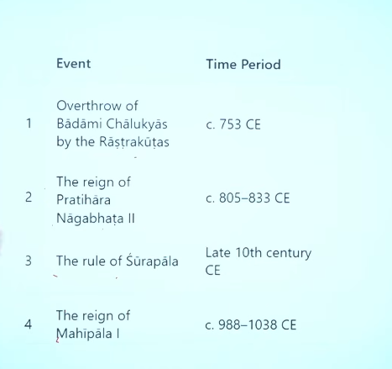

17
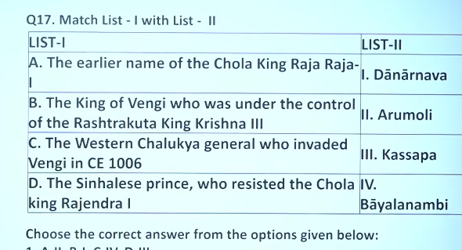
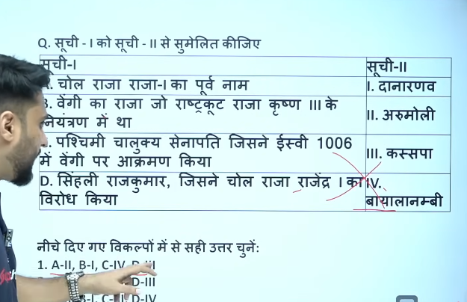

18
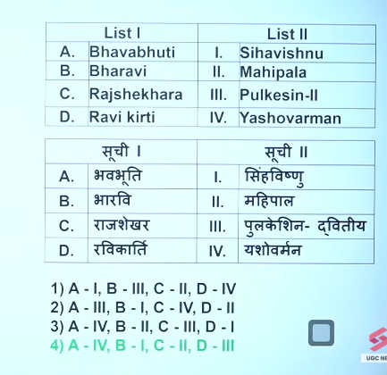

19
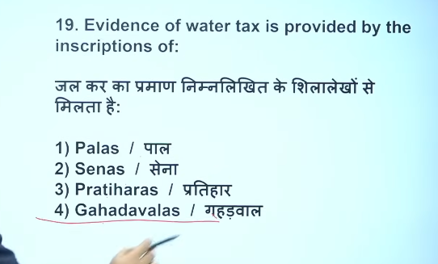
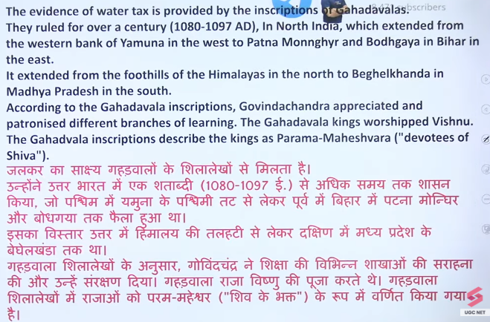
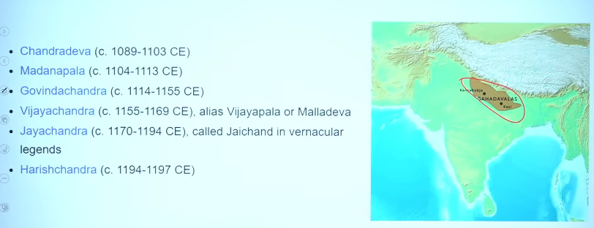

20
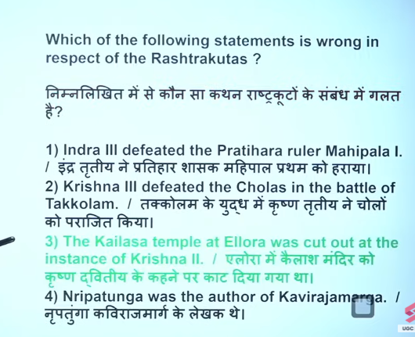
एलोरा का कैलाश मंदिर कृष्ण द्वितीय के आदेश पर बनवाया (या कटवाया) गया था।
- at the instance of = के आदेश पर / के कहने पर
- cut out = चट्टानों को काटकर बनाया गया
- एलोरा का कैलाश मंदिर राजा कृष्ण द्वितीय के कहने पर चट्टानों को काटकर बनाया गया था।

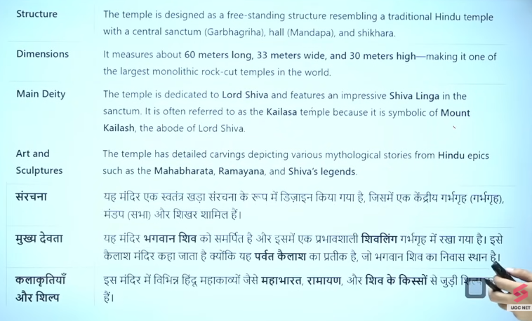
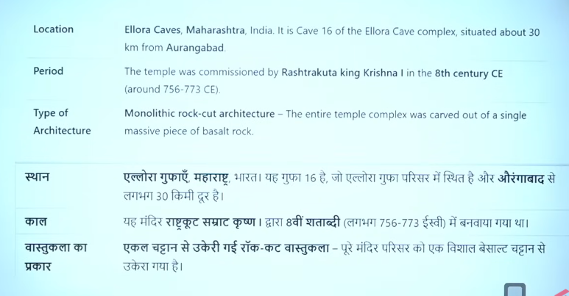

21
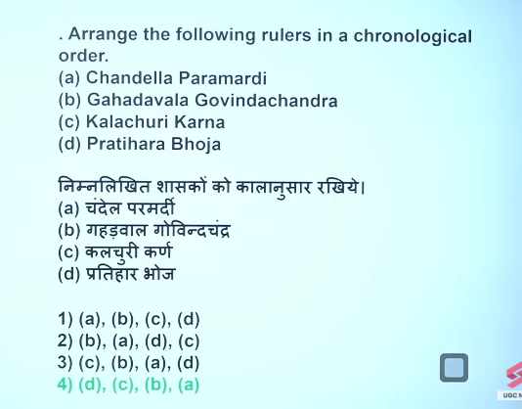
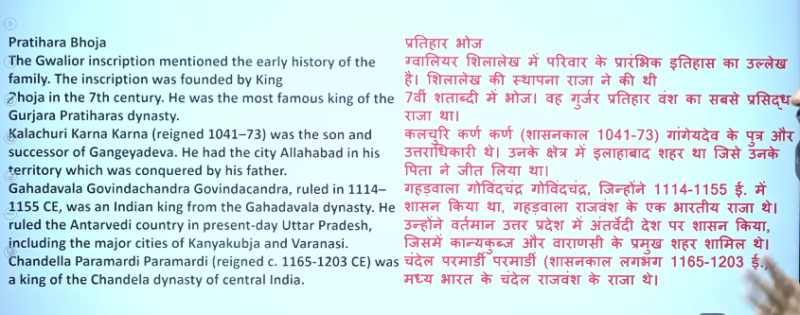

22
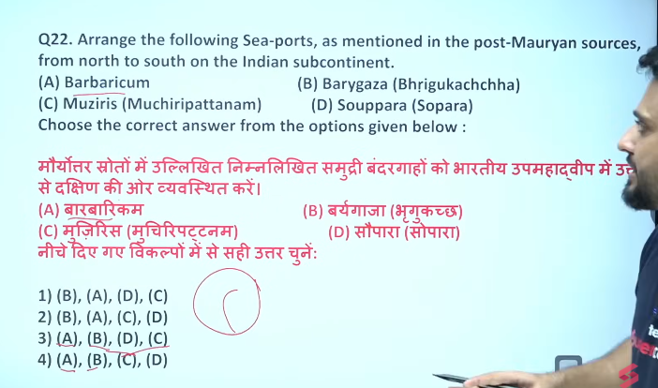
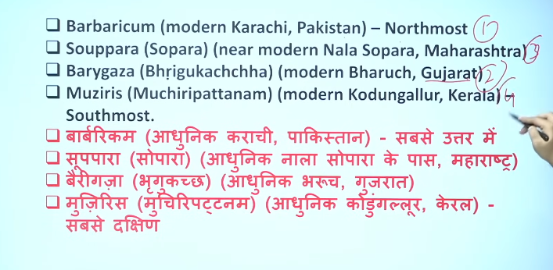

23
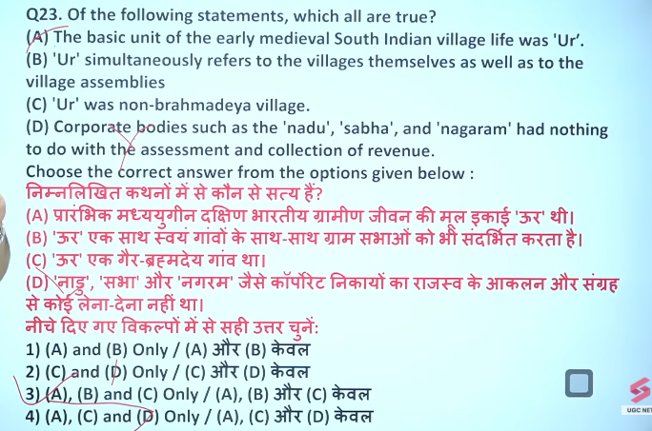

24
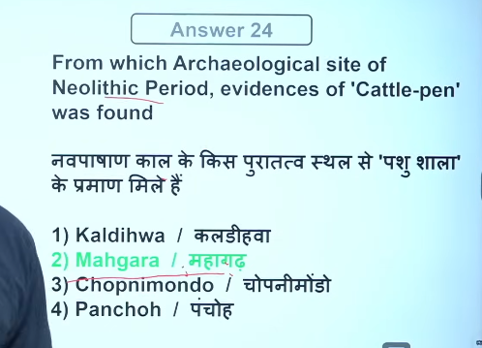
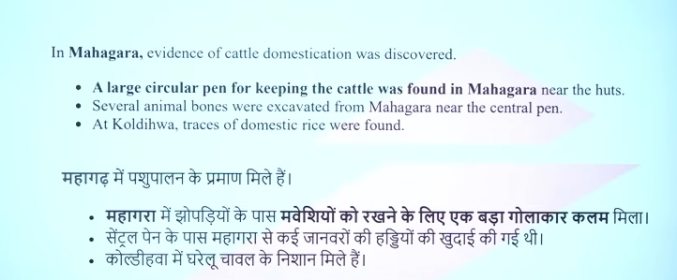

25
